Бекітемін: _____________________

Қысқа мерзімді жоспар
№78 жалпы білім беретін мектеп-гимназия
(білім беру ұйымының атауы)
Ағылшын тілі

Unit 4 | The world of work
Teacher name: | Adilova U.Zh.
Date: | 02.12.24
Grade: 5 “v” | Number present: | absent:
Lesson title | Jobs
Learning objectives | 5.3.6.1 communicate meaning clearly at sentence level during, pair, group and whole class exchanges;  5.5.3.1 write with support factual descriptions at text level which describe people, places and objects;
Lesson objectives | Learners will be able to:  -present/practise new vocabulary  -match descriptions to jobs
Value links | “A nation united in strength will succeed”  This is a great trait for a professions.
Plan

Parts of the lesson/ Time | Teacher`s activity | Students` activity | Assessment criteria | Resources
Beginning of the lesson  Warming-up    3 min  Checking up the homework  4 min  Pre-learning  «Brainstorming» method  3 min. | Organization moment :  1.Greeting.  Ask about the weather.  2. Warm-up. Let`s sing a song.  3.Let`s check your homework by WORDWALL  4. Brainstorming. Look at the picture and try to guess today`s lesson theme.  Division in three groups: 1.Doctor  2.Baker  3.Cashier  The teacher sets the lesson objectives, letting students know what to anticipate from the lesson.  Lead – In | Students respond to the teacher`s greeting and take their places.  Students of the class are listed.  Students sing a song  Students check their homework.  Students tried to guess  e.g.teacher, doctor,works  Students say different words from the picture  Students' attention is drawn to the lesson.  Determines the topic and purpose of the lesson | The teacher to assess learners for their ability.  “Good job!  Well done!”  Formative Assessment    Reward stickers  Classdojo    Descriptor:  - write the sentences in the correct order 2  Total: 2 points | PPT-1  Pictures  classdojo  https://teach.classdojo.com/#/classes/66f9a2d43428b17c9dedc8d5/points  Wordwall  https://wordwall.net/resource/83034108/english/homework-unit-3  Excel 5  Student’s book p 45
Middle of the lesson  Presentation part  7 min  Pair work  6 min  Individual work  6 min  Group work  11 min | Present the new words to the students.  •Go through the list of jobs A-H and play the recording. Ss listen and repeat chorally and/or individually.  Task 1.Vocabulary game What does she/he do?  New vocabulary that we will use during the lesson.  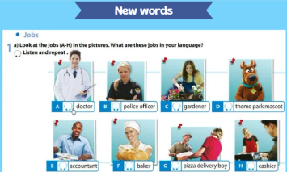  Task 2. Let`s assemble the “puzzle” pieces  • Go through the job descriptions and explain/ elicit the meanings of any unknown words.  • Give Ss time to match the descriptions to the pictures and then check Ss' answers.  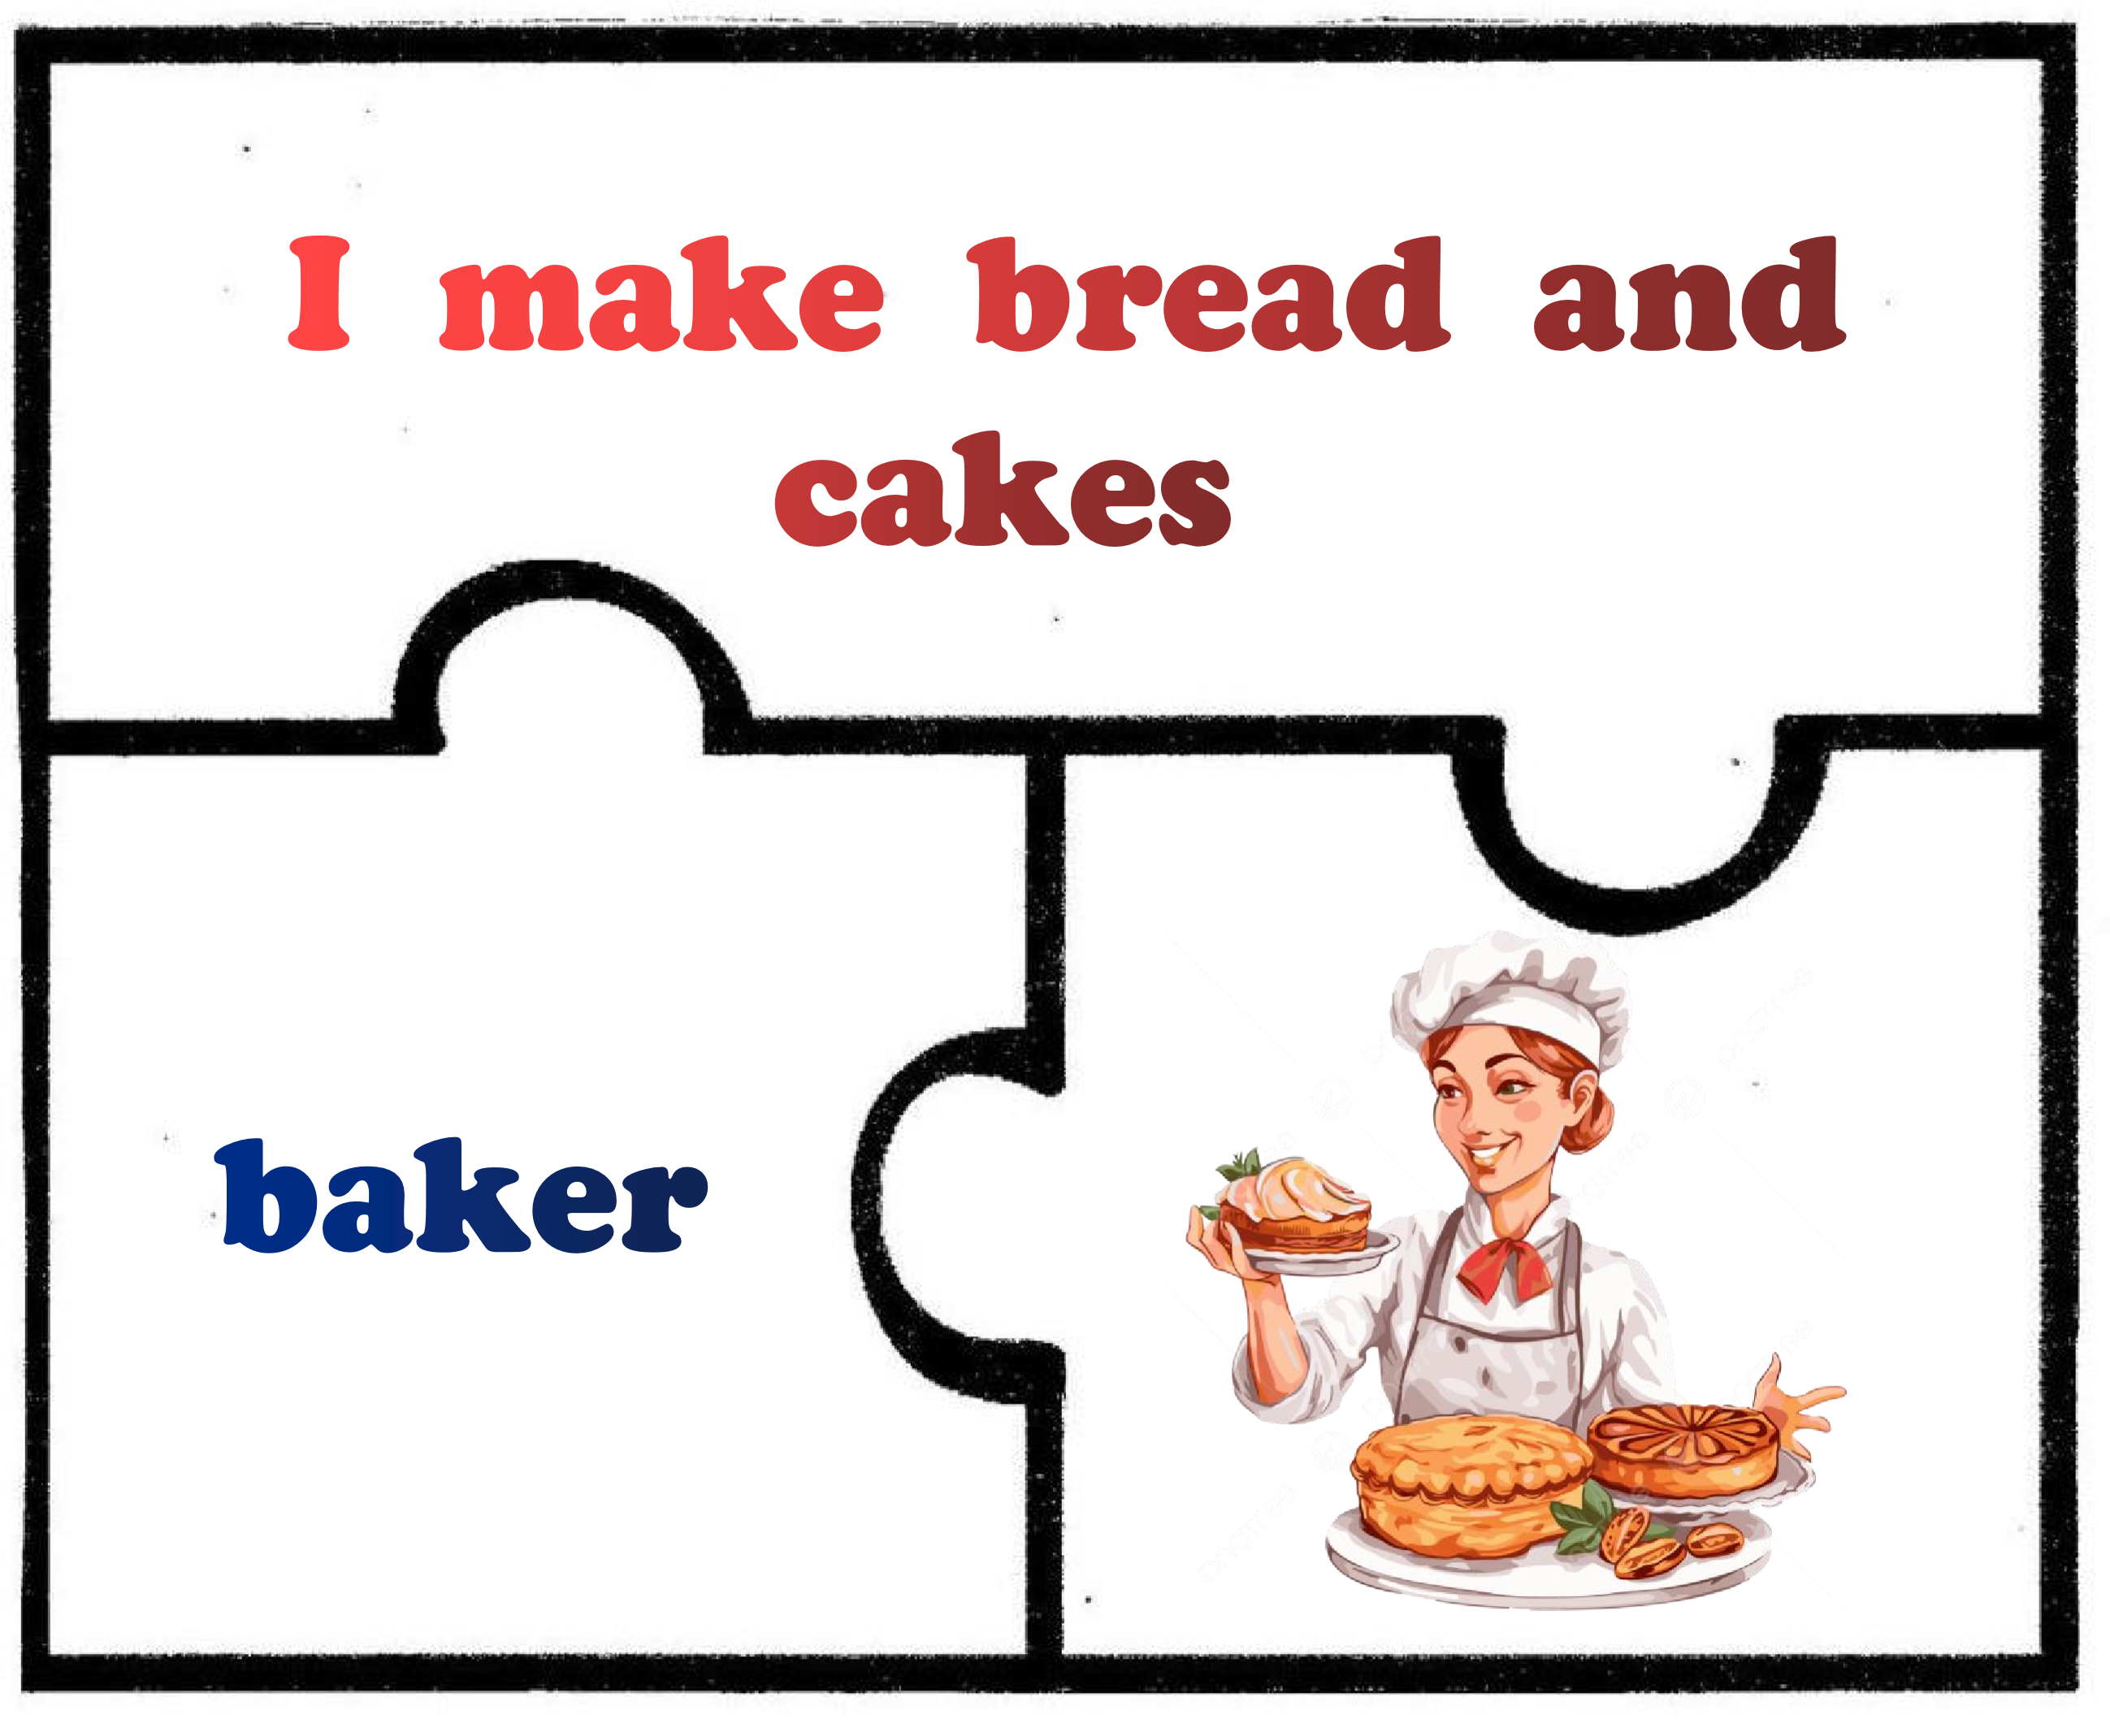  Task 3. Individual work  Teacher explains the task. List the jobs under the headings: outdoors and indoors  • Explain/Elicit the meanings of any unknown words and read out the example.  • Then elicit answers from Ss around the class.  Task 4. Group work “My job” role-playing  In groups, make a short dialogue by following names of groups. Take the roles and act out your dialogue.    “Who is this?”game with  Bamboozle platform Choose the correct answer. Use the dictionary for check yourself.  Conclusion during the lesson some tasks differentiated by outcomes of the students and by their abilities. | Students look at the jobs in the pictures.  Students repeat the vocabulary after the teacher  Students say individually their answer with hand pointer.  e.g.He is a doctor.  She is a baker.  She is a casier.  Students work in pairs.  Students elicit the meanings of any unknown words  Match the puzzle pieces  Students tell the class.  Students elicit meaning of outdoors and indoors.  Students list the jobs into two columns.  Students tell the class.  Students check their answer.  Students work in groups.  Students make a short dialogue.  Students take the roles and act out their dialogue.  e.g. In the shop:  -Good afternoon! Can I help you?  -Yes, tell me please, how much do these apples cost? etc.  Students choose correct answer  Students check their answer. | Oral feedback and correction if necessary.  Excellent! Super!    Reward stickers  Descriptor:  - match and say 1  Total: 1 point  Classdojo    “Good job!  Well done!”  Descriptor:  - work in pairs 1  - assemble the puzzle pieces 1  Total: 2 point  Classdojo  Oral feedback and correction if necessary.  Excellent! Super!    Reward stickers  Descriptor:  - list the jobs under the headings: outdoors and indoors 2  Total: 2 points  Classdojo    Oral feedback and correction if necessary.  Perfect! Super!  Reward stickers  Descriptor:  - make a short diaologue 1  -use an active vocabulary 1  -act out your dialogue 1  Total: 3 points  Classdojo |   Video  Cards  Hand pointer  PPT-6  https://www.canva.com/design/DAF173whFss/5xyN9LQGohIzpspUUwIJhg/edit  Puzzle  PPT-7  https://www.canva.com/design/DAF173whFss/5xyN9LQGohIzpspUUwIJhg/edit  PPT-8  special clothes,  equipments,  cash  Bamboozle  https://www.baamboozle.com/game/1964405
End of the lesson  5 min | FEEDBACK  “Inside out”  Learners provide feedback on what they have learned at the lesson and how did they feel.  Home task: Ex2,p45 Learn new words by heart. | Students choose one character and explain why he/she chose.  Write their feedback and put it. |  | Poster Success  

